4GQ25.JPG

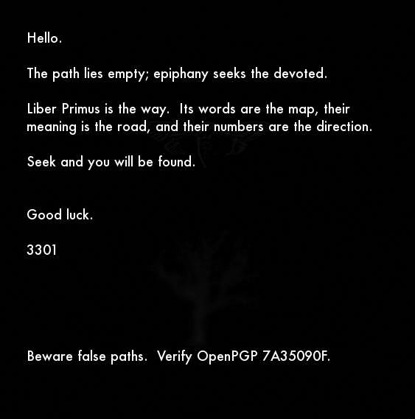4gq25.jpg

[**OutGuess**](https://www.3301archive.com/4gq25-jpg-outguess/) :::::: [**Processed Image**](https://www.3301archive.com/4gq25-jpg-processed/)

**Summary**:  
On **January 5th, 2016**, [Cicada’s official Twitter account](https://twitter.com/1231507051321) tweeted [a link](https://twitter.com/1231507051321/status/684596461628223488) to [infotomb.com/4gq25.jpg](https://t.co/LxS3RDz2AC?amp=1) . This link no longer works, as Infotomb is now non-functional. This link led to 4gq25.jpg  
The apparent purpose of this image seems to be to confirm the status of [Liber Primus](https://www.3301archive.com/liber-primus/) as Cicada’s active challenge — as well as to warn against pursuing [the puzzles of imitators](https://www.3301archive.com/fakes/).

**Size**:  
563 x 569 ***(both prime)*** , 25.7KB ***(257 is prime)***

**Notes:**

**+** Two figures can be seen faintly in the background of *4gq25.jpg* : a cicada and an oak tree — both also found in Liber Primus.  
————

**\*** Given *4gq25.jpg*‘s use of the phrase ‘**epiphany** seeks the devoted’, and the image’s release date of **January 5th**, it should be noted that **January 6th** is the traditional date of the Christian holiday ‘[**Epiphany**](https://en.wikipedia.org/wiki/Epiphany_(holiday))‘, which celebrates the Theophany of Christ.

**\*\*** The word ‘**Epiphany**‘ has been used before. In [zN4h51m.jpg](https://www.3301archive.com/zn4h51m-jpg/), the opening image of the 2014 round released on **January 6th, 2014**, the phrase ‘**Epiphany is upon you.**‘ was used.

**\*\*\*** Cicada’s three annual challenges (2012, 2013, 2014) were released, respectively, on:  
[**January 4th**](https://www.3301archive.com/2012-walkthrough/)**,**[**January 5th**](https://www.3301archive.com/2013-walkthrough/)**, and**[**January 6th**](https://www.3301archive.com/2014-walkthrough/)**.**

# 4GQ25.JPG OUTGUESS

-----BEGIN PGP SIGNED MESSAGE-----

Hash: SHA1

Hello.

The path lies empty; epiphany seeks the devoted.

Liber Primus is the way. Its words are the map, their

meaning is the road, and their numbers are the direction.

Seek and you will be found.

Good luck.

3301

Beware false paths. Verify OpenPGP 7A35090F.

-----BEGIN PGP SIGNATURE-----

Version: GnuPG v1

iQIcBAEBAgAGBQJWhcHDAAoJEBgfAeV6NQkP8GUP/iDXI/9lqvu/HTCujpPcIgYJ

H0Z8FdHDjz86A9yeyXYEUwPu1cLjSNUyGLBlu5dXuGpakuVeHtHnocuwrY24E2o4

Bnaqd1U8hUVU4Y68Va+jRIKS2NrPwg+HFFHr44DHKLHBM4CRqhLBFin36CeUIWmi

jykPMWwrLgxLy8FNXHvN/Fxqt0dbZ6/g1pxM2XOVEvy8bW/Xj7rj3VJGFOL7YVmM

Lae2PuCbmLZD/gaIhbGcPG7NEyUpFBbKEZ6Ul5i5LMeaRgS6KJHwLykeYdGWn65v

j8uY8+5zLBYus/OdbAZiiY6FnOgU/ESRQChQZILxiUIVT/OtFjz5IHrcVg3otoHl

tVfnSvqEk/AJ+w/MscTIBdxLPuvHmYD1B1XK/uZCRP/Dby6x8NFAR/zKAsqzkTY7

E4m34JzcPdsTnla0zmnz/O90jijfH+QAogyZSuEpdJIJlyFSzvDwhDme55gIAC0x

E1W7mxiOdss+Ebbmyyv4ul+l0UCB3qzfLw2Vijxmw/nWoDRqKk6kJf9vWL05BRu9

RoAap3rh0AC7SCV3fHjQj5VOUEJzHoz4YzrK15sa7SOZfeiP6XpfdzZfesiAWI8x

MUiyTFIqCeWZWJoSIe/1yFtumTkXO8/Dn0SCx9D4R6DVSiM9PRSdYgzT/+oRlIEl

Y8f7hrgdyn31uqGUgV4q

=sKXT

-----END PGP SIGNATURE-----

# 4GQ25.JPG PROCESSED

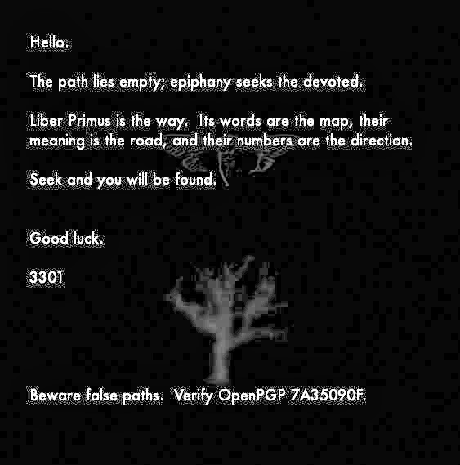4gq25.jpg processed

This is just a version of 4gq25.jpg whose contrast and brightness levels have been adjusted so that the cicada and oak tree figures are more visible. The blocks throughout the background are image compression artifacts, not QR code.